Comprehensive Assignment 03
Evidence
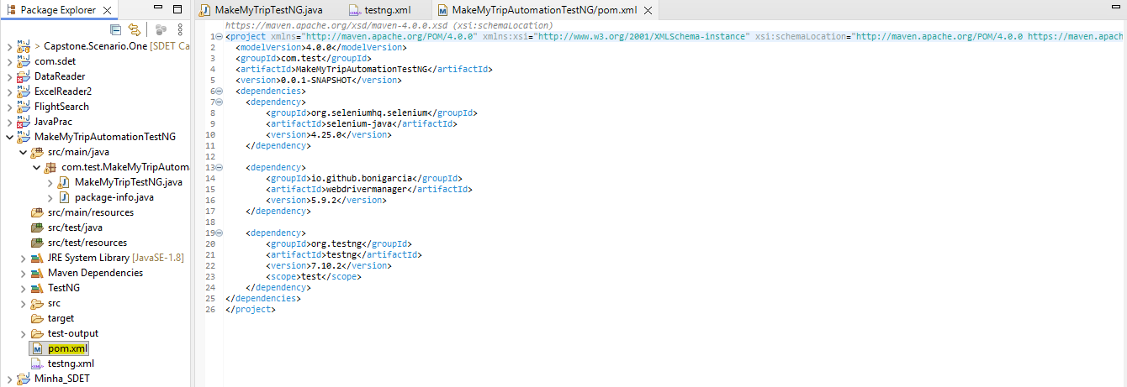
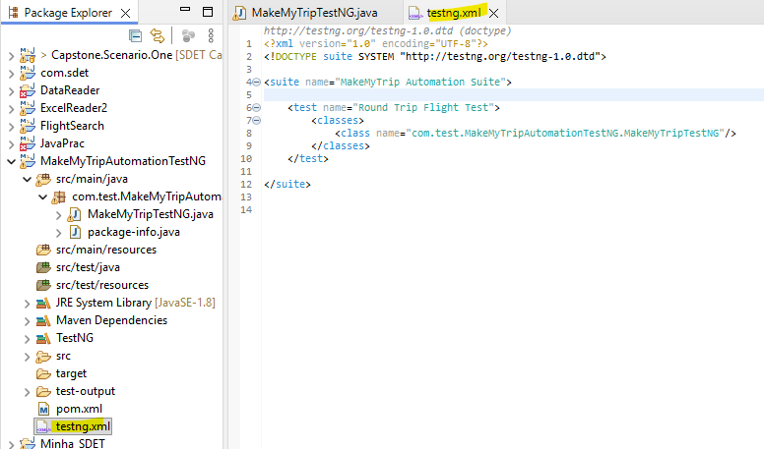
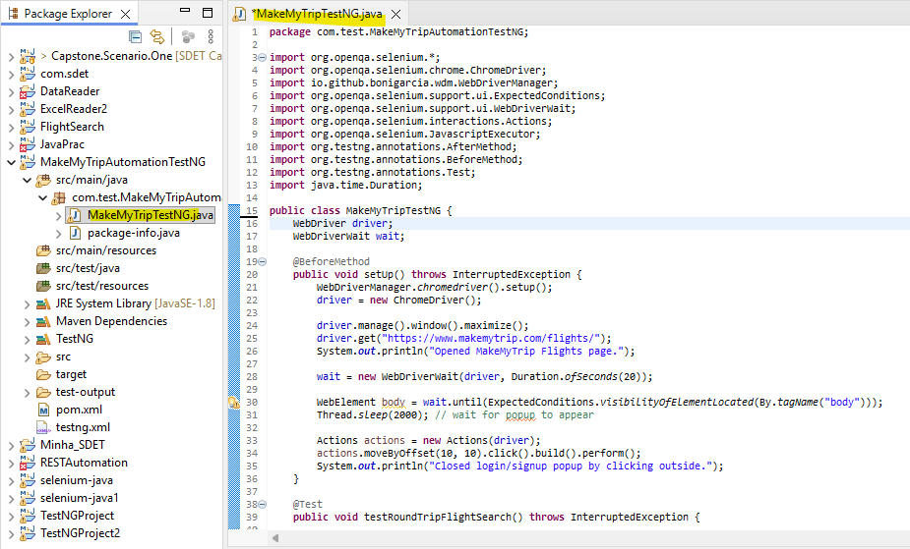
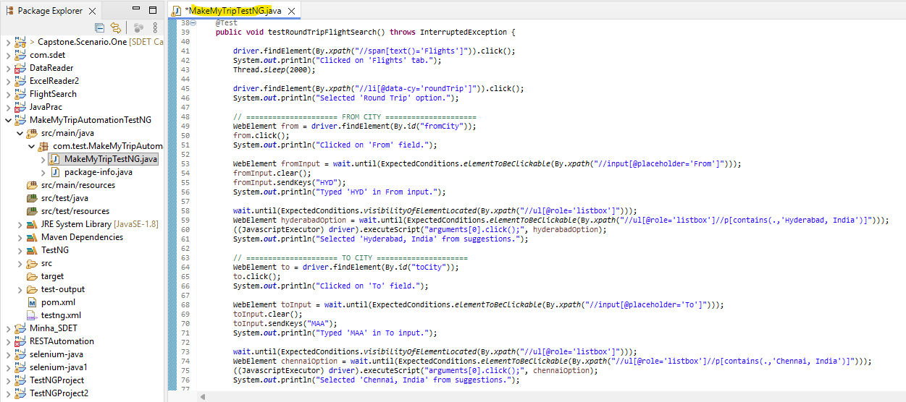
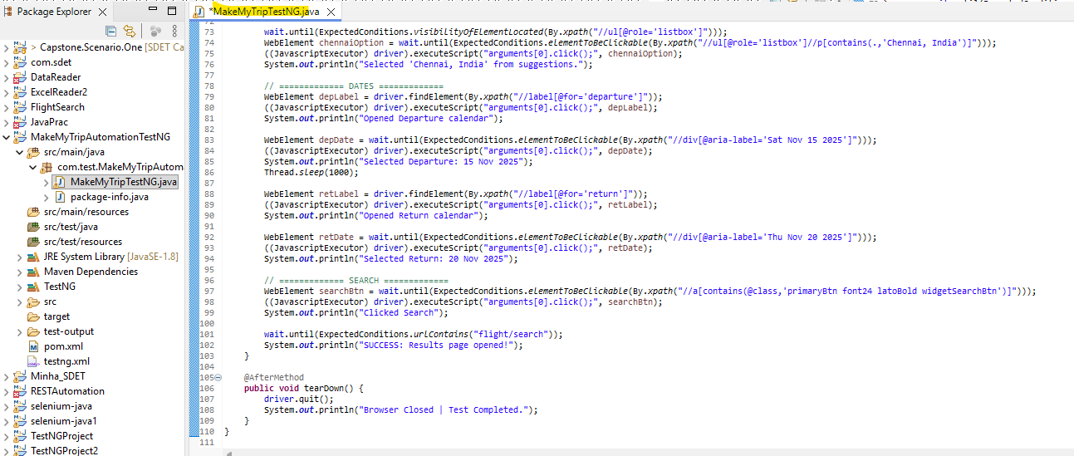
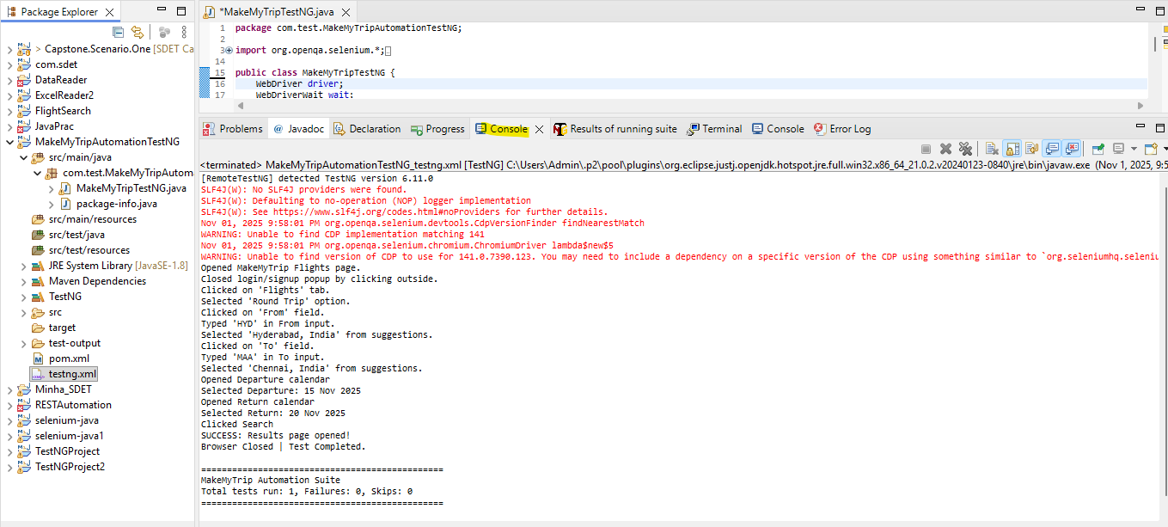
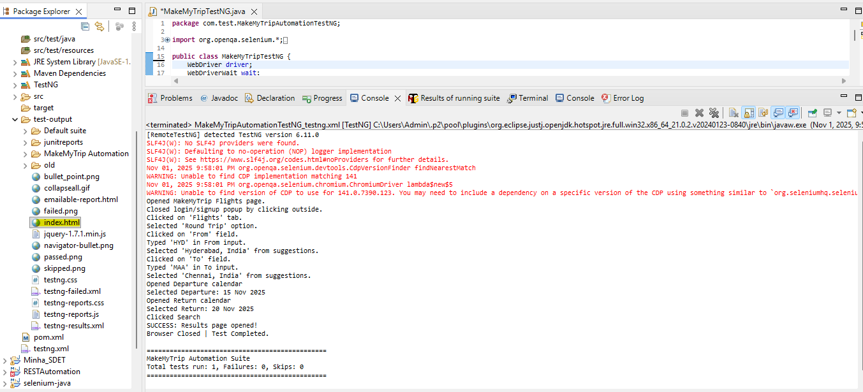
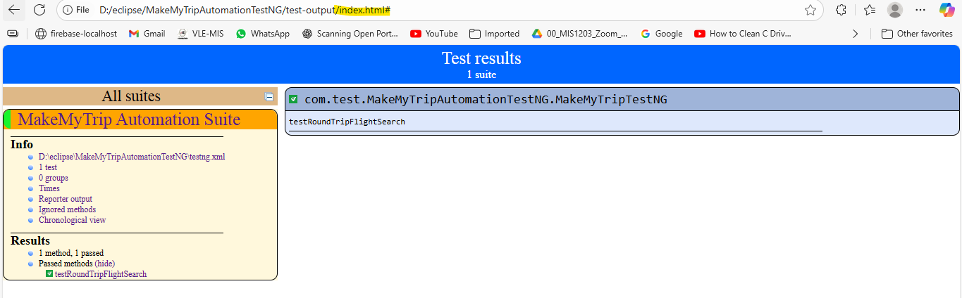
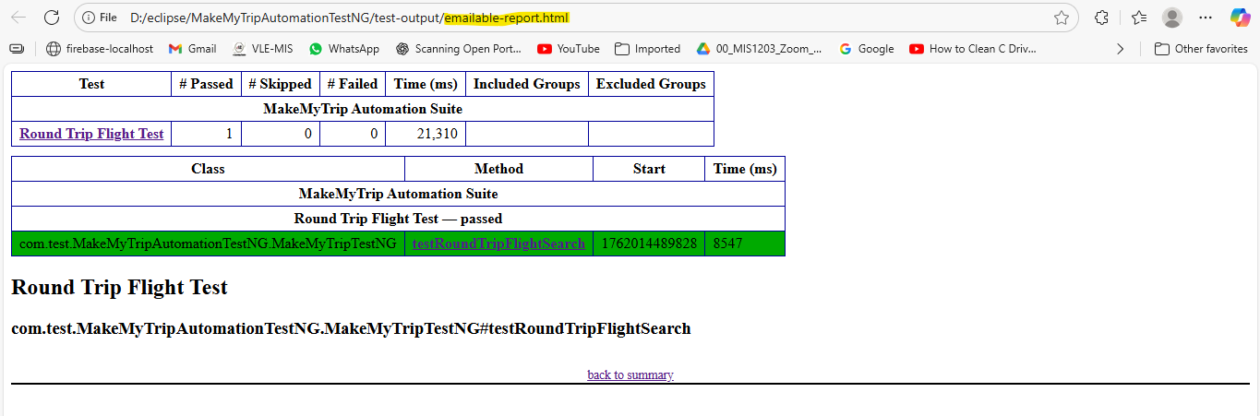
package com.test.MakeMyTripAutomationTestNG;

import org.openqa.selenium.*;
import org.openqa.selenium.chrome.ChromeDriver;
import io.github.bonigarcia.wdm.WebDriverManager;
import org.openqa.selenium.support.ui.ExpectedConditions;
import org.openqa.selenium.support.ui.WebDriverWait;
import org.openqa.selenium.interactions.Actions;
import org.openqa.selenium.JavascriptExecutor;
import org.testng.annotations.AfterMethod;
import org.testng.annotations.BeforeMethod;
import org.testng.annotations.Test;
import java.time.Duration;

public class MakeMyTripTestNG {
WebDriver driver;
WebDriverWait wait;

@BeforeMethod
public void setUp() throws InterruptedException {
WebDriverManager.chromedriver().setup();
driver = new ChromeDriver();

driver.manage().window().maximize();
driver.get("https://www.makemytrip.com/flights/");
System.out.println("Opened MakeMyTrip Flights page.");

wait = new WebDriverWait(driver, Duration.ofSeconds(20));

WebElement body = wait.until(ExpectedConditions.visibilityOfElementLocated(By.tagName("body")));
Thread.sleep(2000); // wait for popup to appear

Actions actions = new Actions(driver);
actions.moveByOffset(10, 10).click().build().perform();
System.out.println("Closed login/signup popup by clicking outside."); }

@Test
public void testRoundTripFlightSearch() throws InterruptedException {

driver.findElement(By.xpath("//span[text()='Flights']")).click();
System.out.println("Clicked on 'Flights' tab.");
Thread.sleep(2000);

driver.findElement(By.xpath("//li[@data-cy='roundTrip']")).click();
System.out.println("Selected 'Round Trip' option.");

// ===================== FROM CITY =====================
WebElement from = driver.findElement(By.id("fromCity"));
from.click();
System.out.println("Clicked on 'From' field.");

WebElement fromInput = wait.until(ExpectedConditions.elementToBeClickable(By.xpath("//input[@placeholder='From']")));
fromInput.clear();
fromInput.sendKeys("HYD");
System.out.println("Typed 'HYD' in From input.");

wait.until(ExpectedConditions.visibilityOfElementLocated(By.xpath("//ul[@role='listbox']")));
WebElement hyderabadOption = wait.until(ExpectedConditions.elementToBeClickable(By.xpath("//ul[@role='listbox']//p[contains(.,'Hyderabad, India')]")));
((JavascriptExecutor) driver).executeScript("arguments[0].click();", hyderabadOption);
System.out.println("Selected 'Hyderabad, India' from suggestions.");

// ===================== TO CITY =====================
WebElement to = driver.findElement(By.id("toCity"));
to.click();
System.out.println("Clicked on 'To' field.");

WebElement toInput = wait.until(ExpectedConditions.elementToBeClickable(By.xpath("//input[@placeholder='To']")));
toInput.clear();
toInput.sendKeys("MAA");
System.out.println("Typed 'MAA' in To input.");

wait.until(ExpectedConditions.visibilityOfElementLocated(By.xpath("//ul[@role='listbox']")));
WebElement chennaiOption = wait.until(ExpectedConditions.elementToBeClickable(By.xpath("//ul[@role='listbox']//p[contains(.,'Chennai, India')]")));
((JavascriptExecutor) driver).executeScript("arguments[0].click();", chennaiOption);
System.out.println("Selected 'Chennai, India' from suggestions.");

// ============= DATES =============
WebElement depLabel = driver.findElement(By.xpath("//label[@for='departure']"));
((JavascriptExecutor) driver).executeScript("arguments[0].click();", depLabel);
System.out.println("Opened Departure calendar");

WebElement depDate = wait.until(ExpectedConditions.elementToBeClickable(By.xpath("//div[@aria-label='Sat Nov 15 2025']")));
((JavascriptExecutor) driver).executeScript("arguments[0].click();", depDate);
System.out.println("Selected Departure: 15 Nov 2025");
Thread.sleep(1000);

WebElement retLabel = driver.findElement(By.xpath("//label[@for='return']"));
((JavascriptExecutor) driver).executeScript("arguments[0].click();", retLabel);
System.out.println("Opened Return calendar");

WebElement retDate = wait.until(ExpectedConditions.elementToBeClickable(By.xpath("//div[@aria-label='Thu Nov 20 2025']")));
((JavascriptExecutor) driver).executeScript("arguments[0].click();", retDate);
System.out.println("Selected Return: 20 Nov 2025");

// ============= SEARCH =============
WebElement searchBtn = wait.until(ExpectedConditions.elementToBeClickable(By.xpath("//a[contains(@class,'primaryBtn font24 latoBold widgetSearchBtn')]")));
((JavascriptExecutor) driver).executeScript("arguments[0].click();", searchBtn);
System.out.println("Clicked Search");

wait.until(ExpectedConditions.urlContains("flight/search"));
System.out.println("SUCCESS: Results page opened!"); }

@AfterMethod
public void tearDown() {
driver.quit();
System.out.println("Browser Closed | Test Completed."); }}

